# CS 255 System Design Document Template

This template lays out all the different sections that you need to complete for Project Two. Each section has guidance to prompt your thinking. You will need to continually reference the interview transcript as you work to make sure that you are addressing your client’s needs. There is no required length for the final document. Instead the goal is to complete each section based on what your client’s needs are. Remove this note when you are finished, and replace all bracketed text with the relevant information.

## UML Diagrams

### UML Use Case Diagram

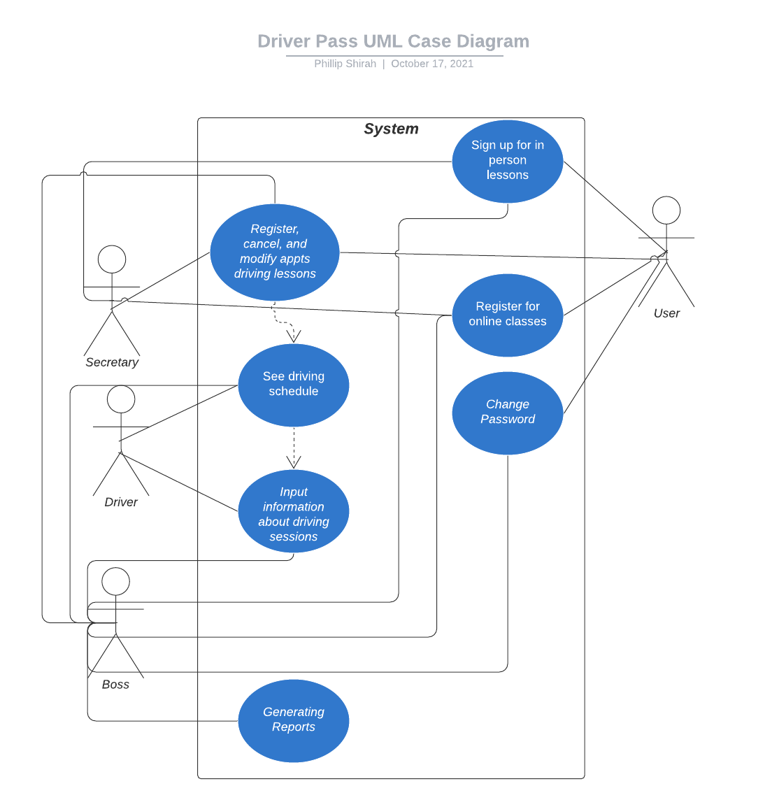

### UML Activity Diagrams

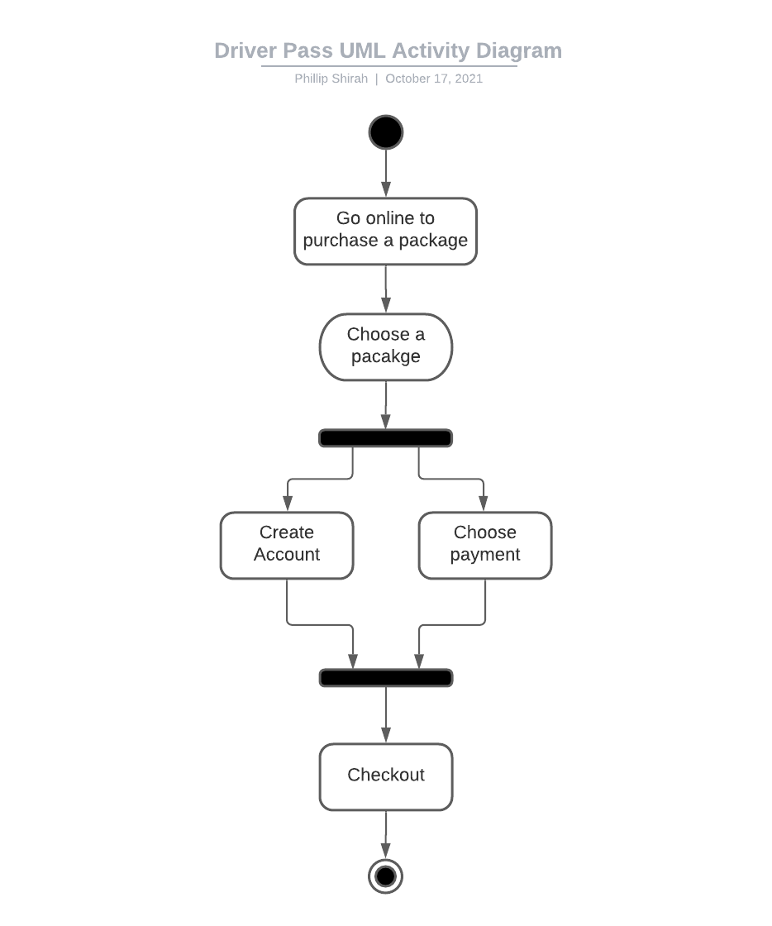

### UML Sequence Diagram

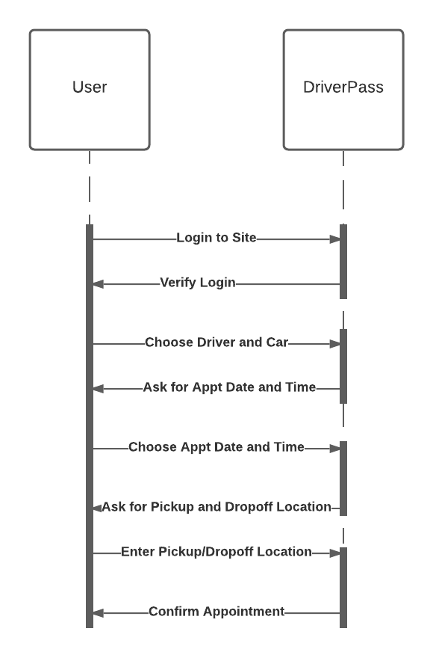

### UML Class Diagram

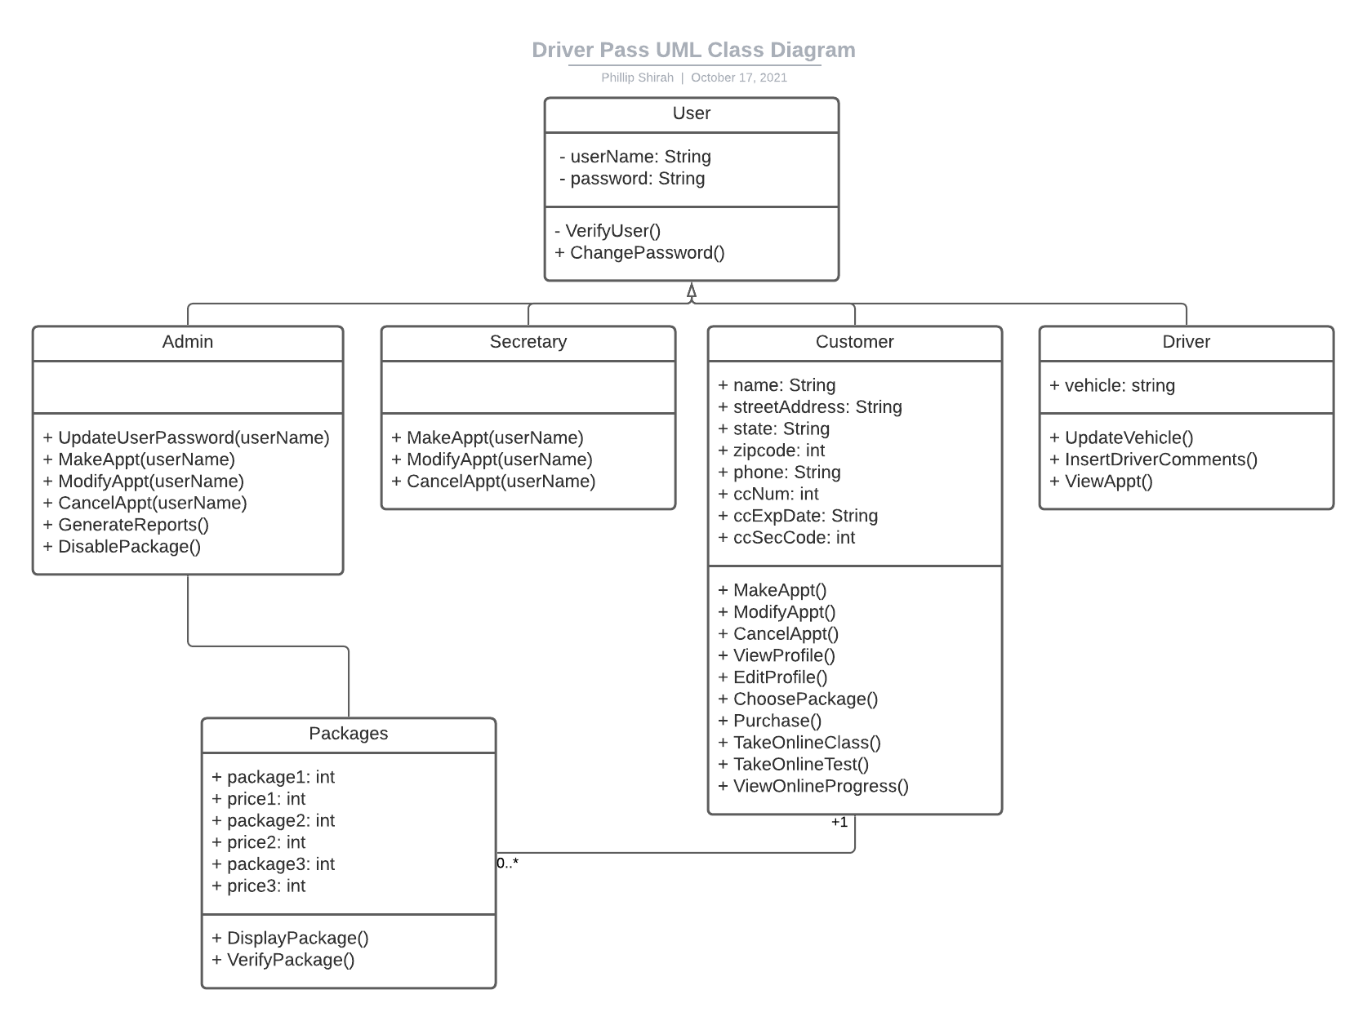

## Technical Requirements

**Server:**

* Serverless cloud platform
  + Best economical for small business.
  + Doesn’t have to maintain a physical server, security, etc…
  + Allows for easy scaling and VM instances
* Payment gateway (Stripe, Paypal, Etc..)

**Business:**

* Office Computer for Secretary
  + Desktop computer, mouse, monitor, keyboard
* High Speed Internet Access
* Business phone
  + Multi-line
* Laptop for Boss
  + Desktop dock for laptop
* Tablet or Laptop for Driver
  + Mobile Data Capabilities
* GPS tracker for Cars
  + Could potentially be built into tablet for drivers

**Customer:**

* Computer/Smartphone/Tablet
  + Web browser
* Internet access
  + Home Internet
  + Mobile Data
  + Free Wi-fi Hotspot